Housing and Residential Education Annual Report

2022-23

June 30, 2023

Dr. Kelly L. Thacker

Executive Director Housing and Residential Education

Division of University Inclusivity & Student Affairs

Table of Contents

Mission Statement 3

Student Learning Outcomes 3

Housing and Residential Education Residential Curriculum 3

Data Reporting (Programs/Services) Year over Year Comparisons 5

Fall 2018-2022 5

Spring 2019-2023 6

Summer 2019-2023 7

Current Org Chart- 8

Signature Events (departmental major events) 8

Housing Move-In & Move-Out 8

ResFest 9

Community Center Takeover 9

Selected Departmental Accomplishments 9

Other (unique to departments) 10

# Mission Statement

***The mission of Housing and Residential Education is to provide a residential environment in which staff and services promote student development within a comprehensive living experience.***

# Student Learning Outcomes

## Housing and Residential Education Residential Curriculum

**Educational Priority**

UW-Green Bay Housing and Residential Education offers residential experiences to enhance learning opportunities outside of the classroom. Through these experiences, students will develop knowledge and skills to advocate for themselves and others, while also being responsible and engaged members of current and future communities.

**Learning Goals and Outcomes**

*Self-Efficacy*

Personal growth and exploration are cornerstones of student development. Students will build proficiency in identifying and verbalizing needs, ideas, thoughts, and values. Students will also have a broad understanding of the impact of actions on others and the community.

* As a result of living on campus, students will be able to identify correlations between actions and values/beliefs.
* As a result of living on campus, students will be able to recognize the importance of building and sustaining positive relationships with others.
* As a result of living on campus, students will be able to develop the ability to determine personal needs and how to fill them.
* As a result of living on campus, students will be able to learn to exert control over behaviors, motivations, and social environments.

*Wellness*

Wellness is a multifaceted concept that encompasses physical, social, emotional, environmental, spiritual, financial, intellectual, and occupational wellbeing. UW-Green Bay residential environments will help students identify, establish, and maintain regular patterns of behavior that promote overall wellness.

* As a result of living on campus, students will be able to define healthy habits regarding behavior-altering substances.
* As a result of living on campus, students will be able to identify campus and local community resources regarding wellness.
* As a result of living on campus, students will be able to assess current personal wellness levels.
* As a result of living on campus, students will be able to develop strategies to improve mental well-being.
* As a result of living on campus, students will be able to clearly articulate the relationship between wellness and one’s capacity to meet personal, academic, and life goals.

*Inclusive Excellence*

UW-Green Bay strives to foster and support inclusive communities which allow students to better understand personal cultural context. By developing competence and confidence, the UW-Green Bay residential communities will encourage residents to understand the importance of diversity, difference, and active inclusion.

* As a result of living on campus, students will be able to discuss how national or global events affect the campus and local community.
* As a result of living on campus, students will be able to relate social justice and inclusion concepts to personal experiences.
* As a result of living on campus, students will be able to describe personal identities.
* As a result of living on campus, students will be able to express an increased confidence in confronting identity-based conflict.
* As a result of living on campus, students will learn skills to break down barriers and create solutions to inequities.
* As a result of living on campus, students will be able to identify marginalized and privileged identities and how these relate to power.

*Sustainability*

UW-Green Bay recognizes the importance of sustaining a healthy campus environment for future Phoenix to come. Students will be empowered to make a positive impact on the environment and learn sustainable practices.

* As a result of living on campus, students will determine one’s social responsibility as future professionals and citizens.
* As a result of living on campus, students will be able to define sustainability and identify major sustainability challenges and opportunities.
* As a result of living on campus, students will be able to apply critical thinking skills to provide sustainable solutions and build resilient communities.
* As a result of living on campus, students will learn how to apply knowledge beyond campus and know what it means to be a green global citizen.

# Data Reporting (Programs/Services) Year over Year Comparisons

## Fall 2018-2022

* + Occupancy (Revenue generating occupancy compared to revenue generating capacity)
    - Fall 17: 100.8%
    - Fall 18: 98.8%
    - Fall 19: 99.4%
    - Fall 20: 73.5%
    - Fall 21: 86.2%
    - Fall 22: 92.30%
    - All occupancy data comes from the 10th day of classes each semester.
  + Maintenance Requests (all submitted requests were completed)
    - Fall 18: 1403
    - Fall 19: 1288
    - Fall 20: 683
    - Fall 21: 1534
    - Fall 22: 1444
    - Totals for entire semester
  + Student Packages Processed in Student Mailroom
    - Fall 18: 14398
    - Fall 19: 12719
    - Fall 20: 11881
    - Fall 21: 13560
    - Fall 22:  8445 (missing July and most of August as a result of transition to StarRez system)
  + Housing Contract Cancellations
    - Fall 18: 3 approved appeals, 42 requests
    - Fall 19: 3 approved appeals, 42 requests
    - Fall 20: 648 approved appeals, 648 requests
    - Fall 21: 97 approved appeals, 195 requests
    - Fall 22: 105 approved appeals, 188 requests (includes withdrawls)
  + Hall Programs
    - Fall 18: 124 programs, 5417 students attended
    - Fall 19: 254 programs, 6540 students attended
    - Fall 20: 54 programs, 1535 students attended
    - Fall 21: 128 programs, 2781 students attended
    - Fall 22: 128 programs, 2276 students attended
    - This data does not include program collaborations with other areas of campus.
  + Intentional Student Conversations
    - Fall 19: 1960 conversations, 3070 students participated
    - Fall 20: 2519 conversations, 5252 students participated
    - Fall 21: 2612 conversations, 6281 students participated
    - Fall 22: 3585 conversations, 7303 students participated
    - Intentional conversations were not tracked prior to 2019-2020

## Spring 2019-2023

* + Occupancy (Revenue generating occupancy compared to revenue generating capacity)
    - Spring 19: 93.2%
    - Spring 20: 94.6%
    - Spring 21: 56.8%
    - Spring 22: 78.7
    - Spring 23: 81.83%
    - All occupancy data comes from the 10th day of classes each semester.
  + Maintenance Requests (all submitted requests were completed)
    - Spring 19: 1083
    - Spring 20: 553
    - Spring 21: 612
    - Spring 22: 1823
    - Spring 23: 1035
    - Totals for entire semester
  + Student Packages Processed in Student Mailroom
    - Spring 19: 10969
    - Spring 20: 7899
    - Spring 21: 8859
    - Spring 22: 11045
    - Spring 23: 9378
  + Hall Programs
    - Spring 19: 137 programs, 4666 students attended
    - Spring 20: 97 programs, 2112 students attended
    - Spring 21: 128 programs, 1975 students attended
    - Spring 22: 125 programs, 2202 students attended
    - Spring 23: 145 programs, 1530 students attended
    - This data does not include program collaborations with other areas of campus.
* Intentional Student Conversations
  + Spring 20: 1207 conversations, 1908 students participated
  + Spring 21: 1347 conversations, 2560 students participated
  + Spring 22: 2553 conversations, 6279 students participated
  + Spring 23: 3063 conversations, 5250 students participated
  + Intentional conversations were not tracked prior to 2019-2020
* Housing Contract Cancellations
  + Spring 2019, 29 approved appeals, 84 requests
  + Spring 2020, 71 approved appeals, 94 requests
  + Spring 2021, 22 approved appeals, 69 requests
  + Spring 2022, 9 approved appeals, 22 requests
  + Spring 2023: 81 approved appeals, 142 requests (includes withdrawls)

## Summer 2019-2023

* 2018: 25 Snowbirds, 37 corporate student interns, 171 students, 6 summer staff, 5 ACs
* 2019: 23 Snowbirds, 23 corporate student interns, 116 students, 3 summer staff, 5 ACs
* 2020: 0 Snowbirds, 0 corporate student interns, 104 students, 0 summer staff, 4 ACs
* 2021: 22 Snowbirds, 25 corporate student interns, 143 students, 7 summer staff, 4 ACs
* 2022: 23 Snowbirds, 29 corporate student interns, 106 students, 10 summer staff, 3 ACs
* 2023: 46 (25 couples) Snowbirds, 36 corporate student intern, 143 students, 10 summer staff (SRAs), 7 desk staff, 24 student custodians, and 3 student maintenance staff, 5 ADs
* AC position transitioned to Assistant Director (AD) position in Fall 2022

# Current Org Chart-

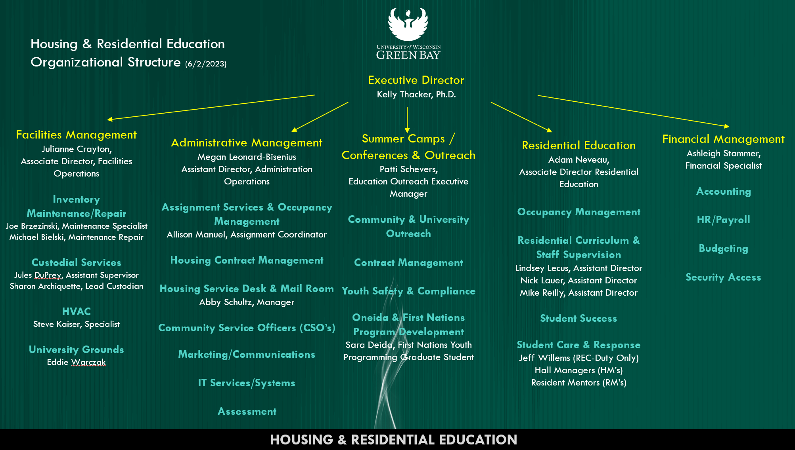

# Signature Events (departmental major events)

## Housing Move-In & Move-Out

* Move In: Smooth move-in process with locks, doors, and wi-fi all working well. Also utilized new StarRez system launched in July 2022.
  + Building meetings were well attended by residents and then transitioned them to the Kress for the Welcome.
  + This was the first year since COVID utilizing volunteers which went well.
* Move Out: Successfully implemented a new check out process utilizing StarRez housing system which allowed for student express check out or to sign up with an RM.
  + Were able to accommodate 100 resident extension requests for graduation involvement and international student travel.
  + Staff also worked together to clear rooms and turn them over to custodial within 48 hours after move out deadline.

## ResFest

* Annual year-end event held by RHAA for housing residents that has been going on for 9 years.
* Held at Bay Beach Amusement Park for third straight year
  + Over 120 students attended. The day was cold & rainy but many students still came out to enjoy the event, especially BINGO.

## Community Center Takeover

* Continued this event for the 2nd year in a row. Developed to have Housing “open house” program during the first two weeks.
* Exposed students to serves provided by Housing desk and allowed students to interact with Housing and University Police staff. Worked to introduce them to the various different ways to interact with staff and the services provided.

# Selected Departmental Accomplishments

* Completed launch and transition of all housing assignment and billing information to Star Rez system in July 2022.
* Modified & implemented new Housing Contract Cancellation appeal process with committee involvement. This committee began meeting and reviewing appeals in April 2023.
  + Committee meets weekly and has representation from; Student Accessibility Services, Wellness Center, Dean of Students, Financial Aid & Housing.
  + Students have the opportunity to request a meeting with the committee to share their personal story and answer committee questions.
* All housing facilities (custodial, maintenance, HVAC) transitioned supervision from Campus Facilities to the Associate Director of Facilities Management in Housing & Residential Education. Julianne Crayton was hired as the Associate Director overseeing this area.
* The Summer Camps & Conferences operation moved from CECE to Housing & Residential Education in February 2023.
  + Patti Schevers was hired as the Education & Outreach Executive Manager overseeing all summer camp & youth programming offerings.
  + Patti worked to hire a new First Nations Youth Programming graduate assistant.  The GA will continue to foster and build relationships within the community. They will assist with the development and ongoing support of programming for Oneida Nation youth.
* Transitioned all mail room & package management to StarRez platform. Has allowed for smooth and seamless student notification and pick-up.
* HRE Leadership team worked collaboratively to develop summer staff positions, position descriptions, pay structure and streamlined hiring process. Worked to provide 24/7 desk & duty coverage through realignment of positions.
* Implemented student self-selection for room assignments through StarRez platform. 1,339 students used this software to select their rooms.
* Launched 2 new residential communities; Sustainability & Level 2 (for upperclass students). Total of 180 students participated in a residential community during the academic year.
* Launched Webinar Series in Summer 2022 to provide monthly opportunities for new students to learn about housing & important information prior to fall move in. Webinar series continued in Summer 2023.
* 79% of RM & HM staff achieved a GPA of 3.0 or higher. The average GPA for student staff was 3.42 for fall and 3.38 for spring.
* Working to streamline software systems utilized by HRE staff team to reduce total number of systems used.
* Worked to hire a Front Desk & Mailroom manager who stared in June 2023. This position has been vacant for over a year and a half.

# Other (unique to departments)

* Highlighted Collaborations Across Campus
  + Admissions
    - Collaborated with the tour team to update the room location to RE Small Hall to better accommodate the tour route.
    - Updated the tour room with new items which hasn’t been done since 2010.
  + Housing Appeal Committee
    - Created revised housing appeal committee process which allows students to share their appeal in writing and/or in person with other university staff. The appeal committee is comprised of staff from DOS, Wellness Center, SAS, and Financial Aid.
  + Facilities/HVAC
    - Continued partnership with facilities staff to help assist housing HVAC staff member to understand systems and annual maintenance.
  + Campus Cupboard & Office of Sustainability
    - Worked to coordinate, organize and donate items from student move out. Donated 24 bushel carts worth of items that included, food, clothing, and household items.
    - Donated 10 bushel carts worth of items to local non-profit.
    - Worked with Office of Sustainability to expand the composting efforts within the residence halls. Available to all students living on campus, not just those in Eco Friendly Phoenix Community.
  + First Nations Studies
    - Partnered with First Nations Studies to revise Oneida Nations Graduate position within Camps & Conferences. Worked to have First Nations staff representation on hiring committee for position.
    - Discussed opportunities for further future partnerships and potential thematic living community in campus housing.
  + University Police
    - Collaborated with University Police for student staff training.
    - Worked with University Police and Dean of Students to revise marijuana response protocol for first 8 weeks of classes.
    - Working to incorporate University Police into service desk and dispatch training.
  + Student Organization Collaborations
    - RHAA & GTP collaborated on student dance event.
    - Housing & Pride Center collaborated on Drag King Bingo & Halloqueen events.
    - Housing Staff & First Gen Phoenix Club collaborated on bingo event.