Housing and Residential Education Annual Report

2023-24

July 1, 2024

Dr. Kelly L. Thacker

Executive Director Housing and Residential Education

Division of University Inclusivity & Student Affairs

Table of Contents

Mission Statement 3

Student Learning Outcomes 3

Housing and Residential Education Residential Curriculum 3

Data Reporting (Programs/Services) Year over Year Comparisons 5

Fall 2019-2023 5

Spring 2020-2024 6

Summer 2020-2024 7

Current Org Chart- 8

Culture of evidence rubric- 8

Signature Events (departmental major events) 8

Selected Departmental Accomplishments 12

Other (unique to departments) 13

STUDENT OUTCOMES for 2024-2025 14

cycle of Assessment Information 15

# Mission Statement

***The mission of Housing and Residential Education is to provide a residential environment in which staff and services promote student development within a comprehensive living experience.***

# Student Learning Outcomes

## Housing and Residential Education Residential Curriculum

**Educational Priority**

UW-Green Bay Housing and Residential Education offers residential experiences to enhance learning opportunities outside of the classroom. Through these experiences, students will develop knowledge and skills to advocate for themselves and others, while also being responsible and engaged members of current and future communities.

**Learning Goals and Outcomes**

*Self-Efficacy*

Personal growth and exploration are cornerstones of student development. Students will build proficiency in identifying and verbalizing needs, ideas, thoughts, and values. Students will also have a broad understanding of the impact of actions on others and the community.

* As a result of living on campus, students will be able to identify correlations between actions and values/beliefs.
* As a result of living on campus, students will be able to recognize the importance of building and sustaining positive relationships with others.
* As a result of living on campus, students will be able to develop the ability to determine personal needs and how to fill them.
* As a result of living on campus, students will be able to learn to exert control over behaviors, motivations, and social environments.

*Wellness*

Wellness is a multifaceted concept that encompasses physical, social, emotional, environmental, spiritual, financial, intellectual, and occupational wellbeing. UW-Green Bay residential environments will help students identify, establish, and maintain regular patterns of behavior that promote overall wellness.

* As a result of living on campus, students will be able to define healthy habits regarding behavior-altering substances.
* As a result of living on campus, students will be able to identify campus and local community resources regarding wellness.
* As a result of living on campus, students will be able to assess current personal wellness levels.
* As a result of living on campus, students will be able to develop strategies to improve mental well-being.
* As a result of living on campus, students will be able to clearly articulate the relationship between wellness and one’s capacity to meet personal, academic, and life goals.

*Inclusive Excellence*

UW-Green Bay strives to foster and support inclusive communities which allow students to better understand personal cultural context. By developing competence and confidence, the UW-Green Bay residential communities will encourage residents to understand the importance of diversity, difference, and active inclusion.

* As a result of living on campus, students will be able to discuss how national or global events affect the campus and local community.
* As a result of living on campus, students will be able to relate social justice and inclusion concepts to personal experiences.
* As a result of living on campus, students will be able to describe personal identities.
* As a result of living on campus, students will be able to express an increased confidence in confronting identity-based conflict.
* As a result of living on campus, students will learn skills to break down barriers and create solutions to inequities.
* As a result of living on campus, students will be able to identify marginalized and privileged identities and how these relate to power.

*Sustainability*

UW-Green Bay recognizes the importance of sustaining a healthy campus environment for future Phoenix to come. Students will be empowered to make a positive impact on the environment and learn sustainable practices.

* As a result of living on campus, students will determine one’s social responsibility as future professionals and citizens.
* As a result of living on campus, students will be able to define sustainability and identify major sustainability challenges and opportunities.
* As a result of living on campus, students will be able to apply critical thinking skills to provide sustainable solutions and build resilient communities.
* As a result of living on campus, students will learn how to apply knowledge beyond campus and know what it means to be a green global citizen.

# Data Reporting (Programs/Services) Year over Year Comparisons

## Fall 2019-2023

* + Occupancy (Revenue generating occupancy compared to revenue generating capacity)
    - Fall 19: 99.4%
    - Fall 20: 73.5%
    - Fall 21: 86.2%
    - Fall 22: 92.30%
    - Fall 23: 97.71%
    - **All occupancy data comes from the 10th day of classes each semester.**
  + Maintenance Requests (all submitted requests were completed)
    - Fall 19: 1288
    - Fall 20: 683
    - Fall 21: 1534
    - Fall 22: 1444
    - Fall 23: 1202
    - **Totals for entire semester**
  + Student Packages Processed in Student Mailroom
    - Fall 19: 12719
    - Fall 20: 11881
    - Fall 21: 13560
    - Fall 22:  8445 (missing July and most of August as a result of transition to StarRez system)
    - Fall 23:  14452
  + Housing Contract Cancellations
    - Fall 19: 3 approved appeals, 42 requests
    - Fall 20: 648 approved appeals, 648 requests
    - Fall 21: 97 approved appeals, 195 requests
    - Fall 22: 13 approved appeals, 38 requests
    - Fall 23: 7 approved appeals, 64 requests
  + **This does not include students who cancelled housing as a result of no longer attending UWGB.**
  + **Total cancellation requests for fall 2023 do include 41 students who never submitted an appeal to the committee.**
  + Hall Programs
    - Fall 19: 254 programs, 6540 students attended
    - Fall 20: 54 programs, 1535 students attended
    - Fall 21: 128 programs, 2781 students attended
    - Fall 22: 128 programs, 2276 students attended
    - Fall 23: 63 programs, 2168 students attended
    - **This data does not include program collaborations with other areas of campus.**
  + Intentional Student Conversations
    - Fall 19: 1960 conversations, 3070 students participated
    - Fall 20: 2519 conversations, 5252 students participated
    - Fall 21: 2612 conversations, 6281 students participated
    - Fall 22: 3585 conversations, 7303 students participated
    - Fall 23: 2975 conversations, 5661 students participated
    - Intentional conversations were not tracked prior to 2019-2020

## Spring 2020-2024

* + Occupancy (Revenue generating occupancy compared to revenue generating capacity)
    - Spring 20: 94.6%
    - Spring 21: 56.8%
    - Spring 22: 78.7
    - Spring 23: 81.83%
    - Spring 24: 88.68%
    - **All occupancy data comes from the 10th day of classes each semester.**
  + Maintenance Requests (all submitted requests were completed)
    - Spring 20: 553
    - Spring 21: 612
    - Spring 22: 1823
    - Spring 23: 1035
    - Spring 24: 969
    - **Totals for entire semester**
  + Student Packages Processed in Student Mailroom
    - Spring 20: 7899
    - Spring 21: 8859
    - Spring 22: 11045
    - Spring 23: 9378
    - Spring 24: 10586
* Housing Contract Cancellations
  + Spring 2020, 71 approved appeals, 94 requests
  + Spring 2021, 22 approved appeals, 69 requests
  + Spring 2022, 9 approved appeals, 22 requests
  + Spring 2023: 17 approved appeals, 64 requests
  + Spring 2024: 14 approved appeals, 66 requests
  + **This does not include students who cancelled housing as a result of no longer attending UWGB.**
  + **Total cancellation requests for Spring 2024 do include 38 students who never submitted an appeal to the committee.**
  + Hall Programs
    - Spring 20: 97 programs, 2112 students attended
    - Spring 21: 128 programs, 1975 students attended
    - Spring 22: 125 programs, 2202 students attended
    - Spring 23: 145 programs, 1530 students attended
    - Spring 24: 49 programs, 1691 students attended
    - **This data does not include program collaborations with other areas of campus.**
* Intentional Student Conversations
  + Spring 20: 1207 conversations, 1908 students participated
  + Spring 21: 1347 conversations, 2560 students participated
  + Spring 22: 2553 conversations, 6279 students participated
  + Spring 23: 3063 conversations, 5250 students participated
  + Spring 24: 2145 conversations, 3930 students participated
  + Intentional conversations were not tracked prior to 2019-2020

## Summer 2020-2024

* 2020: 0 Snowbirds, 0 corporate student interns, 104 students, 0 summer staff, 4 ACs
* 2021: 22 Snowbirds, 25 corporate student interns, 143 students, 7 summer staff, 4 ACs
* 2022: 23 Snowbirds, 29 corporate student interns, 106 students, 10 summer staff, 3 ACs
* 2023: 25 Snowbirds, 36 corporate student intern, 143 students, 10 summer staff (SRAs), 7 desk staff, 24 student custodians, and 3 student maintenance staff, 5 ADs
* 2024: 27 Snowbirds, 52 corporate student intern, 205 students including 9 summer staff (SHAs), 7 desk staff, 41 student custodians, and 6 student maintenance staff. 3 ACs, and 1 Assistant Director.
* **AC position transitioned to Assistant Director (AD) position in Fall 2022, and then back to AC position in Fall 2023.**

# Current Org Chart-

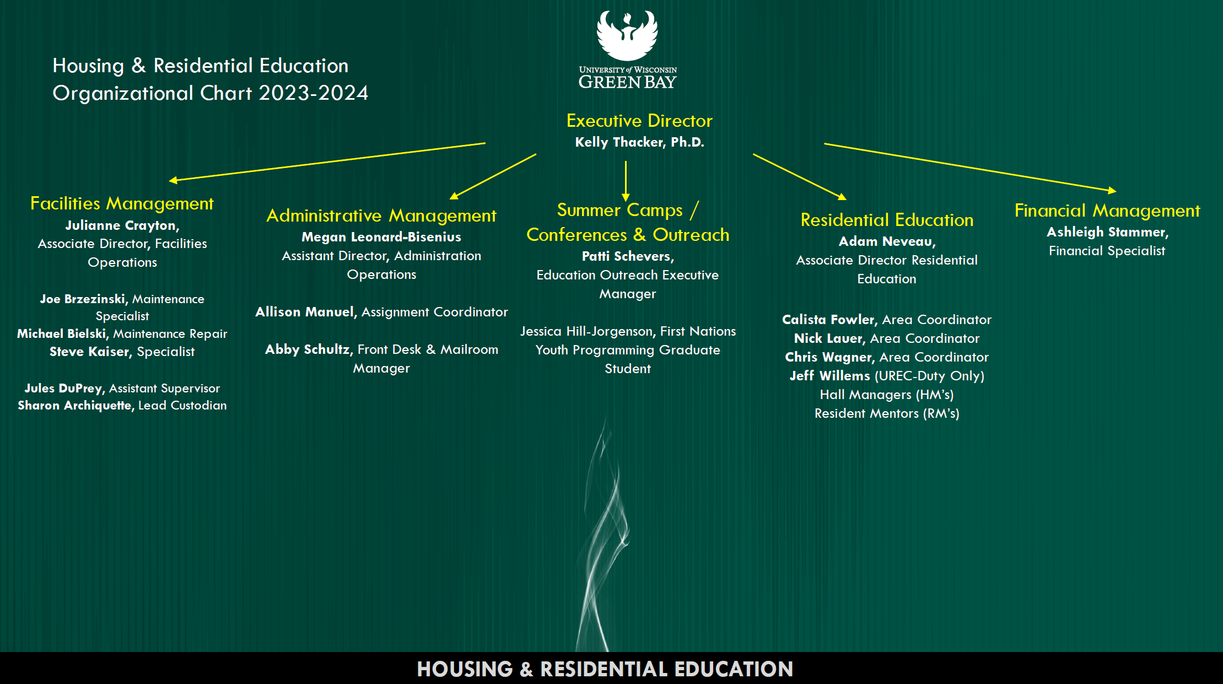

# Culture of Evidence Rubric

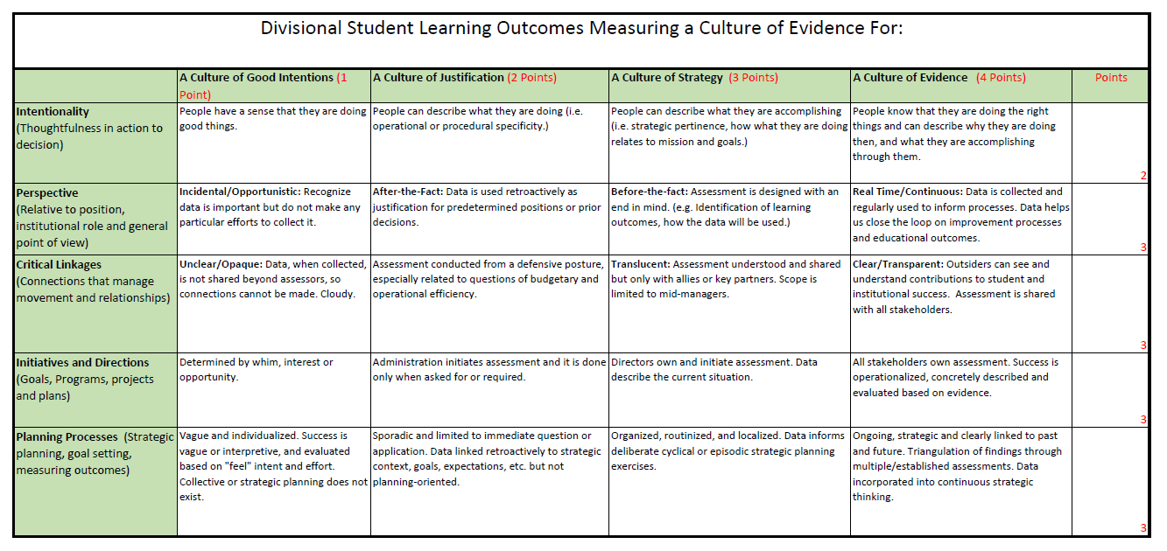

# Signature Events (departmental major events)

## Housing Move-In & Move-Out

* Move In: Smooth move-in process with locks, doors, and wi-fi all working well. Had additional support from various areas on campus. Successfully managed move in around road and construction projects throughout campus.
  + Worked to utilize volunteers from a variety of campus and community areas including outreach to camp and conference groups.
  + Developed a new parking & unloading system for previously congested areas of campus housing, specifically the Roy Dunham Court area. We plan to continue to use this system in future years.
  + Building meetings were well attended by residents and then transitioned them to the Weidner for the Welcome event.
* Move Out: Prepared and created room check out forms that students completed to notify staff when they left campus. Moved out 1,800 students over 2-week period.
  + Continued donation sorting process, helping to restock the Campus Cupboard.
  + Kept the buildings and campus clean throughout the move out weeks by having staff walk floors nightly and contacting residents to remove waste.
  + Created late stay door tags alerting staff of rooms in which students were approved to stay past move out deadline. Total of 289 late stay requests (international students, graduating seniors, summer residents, and student teachers).
  + Reduced total number of rooms in which items were left after move out as a result of consistent communication to students.
  + Increase in hiring of student custodial staff helped reduced total number of contract cleaners needed, also reducing contracted cleaning costs by $30-35,000.
  + Hired summer Facilities Assistant team to provide after-hours facilities support.

## Living Learning & Thematic Communities

* Housing has a variety of thematic and living learning communities (LLC) in which students, faculty, and staff collaborate, meet, and attend programs together. In the living learning communities, students also attend a course together in the fall semester. There was a total of 3 thematic and 3 LLC’s hosted in 7 different campus housing buildings with 186 students members of these communities.
* Over this past year, there were two events hosted by these communities which were well attended by students:
  + The Education LLC hosted a Majors information session. During this event, faculty and advising staff met with students to discuss major opportunities, classes to take, and other involvement opportunities such as the Education Club. This event was open to all education majors on campus.
  + There was also a trip to the Green Bay Farmer’s Market in the fall. This event was open to all students living in a thematic or LLC with most students being a part of the First Gen Phoenix LLC, Education LLC, and Eco-Friendly Phoenix communities. A full bus of 50 students attended this event.

## Online Room Selection & Room Change Process

* Hosted two selection processes online (new and returning students). This is the 2nd year utilizing the Star Rez platform for room selection. Between both processes, had 1,281 students go online to review available spaces and select.
* Opened current resident housing application process (priority) one-month prior (November 1-30, 2023) to all other student access. During this one-month window, 164 students requested to stay in their 2023-24 room assignment for next year. A total of 873 students signed up during the priority process.
* Included a process for sophomore students to select rooms in the newly constructed Cort Condon Hall.
* Moved to an open room change process, allowing students to see availability and change their room daily. This has increased student involvement and reduced staff management of a waitlist process during the summer.

## Summer Camp Preview Days

* In October 2023, at the request of the Ripon School District, hosted 95 youth aged K-5 to spent the day learning about UWGB and camp options. All supplies were provided, including a lunch, snack, and UWGB swag items.
* The cost was $50 per youth with that profit being split among the various program presenters including; Athletics, Cofrin School of Business, CSET, and CAHSS.
* An additional Camp Preview Day was held in Spring 2024 on the Manitowoc campus with 5 youth in attendance.

## ResFest

* Annual year-end event held by RHAA for housing residents that has been going on for 10 years.
* After three years at Bay Beach, the event was brought back to campus in Phoenix Park and the Phoenix Rooms. Included art activities, an outdoor picnic, and inflatable activities.
  + Estimated attendance was 100 students due to various check in locations.

## Community Center Takeover

* Continued this event for the 3rd year in a row.  Developed to have Housing “open house” program during the first two weeks. Will work to implement a spring semester version for 2025 and include housing student organizations.
* Exposed students to serves provided by Housing desk and allowed students to interact with Housing and University Police staff.  Worked to introduce them to the various different ways to interact with staff and the services provided.

# Selected Departmental Accomplishments

* 77% of RM & HM staff achieved a GPA of 3.0 or higher. The average GPA for student staff was 3.27 for fall and 3.36 for spring. 8 of 62 student staff received a GPA of 4.0 for the Fall 2023 semester and 10 of 61 student staff received a GPA of 4.0 for the Spring 2024 semester.
* In the Fall 2023, worked to bring back the student Facilities Assistant (FA) position for the first time since 2013.
  + The 5 FA staff completed work orders and projects during the day while also serving as a part of an on-call team for after-hour maintenance concerns and urgent work orders.
  + This position has allowed housing staff to better provide after hours and weekend response for facilities concerns 24/7/365. The more responsive and timely work order resolution is one way the housing team has worked to increase student satisfaction and retention of residential students.
* Had housing staff representation and volunteers at a variety of community events including; Packer Family Night, Estamos Aquí, Destination Imagination, and Juneteenth.
* Worked to hire 2 Area Coordinators that started in December 2022. These positions were vacant for 4-6 months.
* Housing staff are involved in both regional and state organizations. One staff member serves on the UMR-ACUHO Executive Board as the Engagement Chair, and another on the WCPA Committee as the Involvement Liaison. Additionally, several staff also assist and participate in regular professional development offerings and conferences throughout the year.
* Worked with IT to document and streamline software systems utilized by HRE staff team to reduce total number of systems used. Also working to provide online payment portal for guest housing and an electronic fax system.
* In Summer 2023, 2 housing staff served as faculty members for the Regional Entry Level Institute (RELI) and 2 more staff attended as participants. In Summer 2024, 1 housing staff member served as faculty for RELI, with another staff member attending as a participant.
* Summer Camps & Conferences worked to increase the total number of offerings in summer 2023 & 2024.
  + Summer 2023: Offered 20 camp sessions with 271 youth involved. Includes 32 Oneida youth and 7 DPI scholarship students.
  + Summer 2024: Offered 35 camp sessions with 1128 youth involved. Includes 37 Oneida youth and 6 DPI scholarship students.
  + In Summer 2024 also worked to host 4 camps previously hosted at St. Norbert’s or other campuses including; Lead GB Girls (2 camps), Lead GB Boys (2 camps), Wisconsin DeMolay, and Badgerette Pon Pom.
* Launched Guest Housing program in April 2024 to UWGB faculty, staff, and a variety of Green Bay community members. The goal of this program is to utilize state buildings not being used for student housing, while also providing affordable short or long-term housing options and increasing revenue for housing department.
  + With this launch of these guest option, also created online guest housing request form, digital lease process, and specific guest housing website hosted on the housing website.
  + Since the program launch, have hosted guests from the following organizations; UWGB Athletics & Admissions Staff, UWGB Faculty, UWGB Summer Ambassadors, UWGB Alumnae, Catholic Charities, Green Bay Chamber of Commerce, and Green Bay Packers Interns.
* There were several housing full-time and student staff recognized for their work on campus and in their personal lives including Patti Schevers (Phoenix Green Staff Award) and Nick Lauer (Lavender Leadership Staff of the Year Award). Additionally, 1 current student staff received the Chancellor’s Medallion, and 6 current and former student staff received University Leadership Awards.
* HRE Leadership team worked collaboratively to develop one streamlined summer staff training schedule for May 2024. Worked to include all summer staff positions into the schedule to reduce the need to provide the same training at different times for the staff teams.
* Record setting number of summer housing contracts with over 200 students and 52 interns living on campus throughout Summer 2024.
* Over the past year, worked to increase the total number of summer student cleaning and maintenance staff hired from 24 in summer 2023 to 47 in 2024. This resulted in less need for cleaning contractors and reduced total spent for contractors by $35,000.
* Worked to launch 2 new thematic communities for Fall 2024 with collaboration of faculty; Wellness & Nursing communities.

# Other (unique to departments)

* Highlighted Collaborations Across Campus
  + Admissions
    - Collaborated with the marketing team to update the admitted student housing brochure.
    - Attended several staff meetings to provide housing updates specifically related to room selection.
  + Housing Appeal Committee & Student Accessibility Services (SAS)
    - Held weekly meetings with students and housing appeal committee including staff from DOS, Wellness Center, SAS, and Financial Aid. During each meeting, worked to connect students to needed resources based on personal circumstances.
    - Worked to update the housing website to include information about the housing cancellation and appeal process.
    - Housing staff meet monthly with Housing Accommodations Committee, including SAS and Wellness staff to review student housing accommodation and assistance animal requests.
  + Facilities/HVAC
    - Continued partnership with facilities staff to help assist housing HVAC staff member to understand systems and annual maintenance.
    - Provided tours of heat/chill plant to all Hall Manager and Facility Assistant staff to better understand heating and cooling systems within campus housing buildings.
    - Worked to install air conditioners into select guest units to allow for year-round occupancy.
  + Campus Cupboard & Office of Sustainability
    - Worked to coordinate, organize and donate items from student move out.  Donated 15 bushel carts worth of items that included, food, clothing, and household items.
    - Donated 15 bushel carts worth of items to local non-profit.
  + University Marketing
    - Over a 3-month period, worked to update housing website in new University format and updated all housing information and processes.
    - Hosted groundbreaking event in May 2023 for Cort Condon Hall.
    - Revised format and updated information in Admitted Student brochure included in all Admitted Student packets sent by UWGB.
    - Worked to prepare press releases, ground breaking, and branding for Cort Condon Hall opening in Fall 2024.
  + First Nations Studies (FNS)
    - Provided UWGB & Camps involvement in a variety of events held in Oneida, including the monthly Just Move It Oneida events. UWGB & the First Nation grad attended 9 Just Move It events this past year.
    - First Nations Graduate position shared time and held office hours in both the Housing/Camps & Conference Office as well as FNS.
    - Discussed opportunities for further future partnerships with Phuture Phoneix, Dual Enrollment, and YES Council.
  + University Police
    - Collaborated with University Police for student staff training.
    - Incorporated University Police into service desk and dispatch training in May 2024.
  + Student Organization Collaborations
    - RHAA & GTP collaborated on BINGO event
    - Housing & Pride Center collaborated on Hallowqueen event
    - Housing Staff & First Gen Phoenix Club collaborated on bingo event.

# Student Outcomes for 2024-25

* Work to provide more consistent and clear information related to housing contract, sign up, and room selection processes. This would also include creating effective communication that is streamlined, providing more direction and deadlines related to all housing processes and services.
* Improve and enhance on campus housing students’ sense of belonging by increasing personal interactions with faculty, staff, and other students.
* Educate students about open gender housing, the purpose, benefits, and impact that is has upon the community.
* Educate students about conflict management skills, the importance of confronting challenging people/situations, and how to utilize these skills within a community setting.
* Improve student comprehension and increase their ability to navigate university processes successfully by utilizing multiple formats (online videos, emails, phone calls, in person conversations, and social media).

# Assessment

1. **Cycle of Assessment** 
   * All of the student learning outcomes noted will be assessed in this assessment cycle.
   * There is an annual, longitudinal housing survey, EBI Skyfactor that will be utilized to assess student satisfaction and learning, while also exploring future opportunities for student and staff growth. In the Skyfactor survey, students rate their satisfaction with services and self-assess their learning on a 7-point scale. Results from this survey are compared with other United States based higher education institutions similar in size and educational program scope.
2. **Outcome Assessment Procedure**:
   * The EBI Skyfactor survey will be sent to all on campus housing residents in late October 2024 and the survey will remain open for 4 weeks.
   * After the survey closes, there is immediate access to the survey data. Housing staff review this data from the most recent survey along with longitudinal data to understand student learning from the fall 2024 semester.
   * The data comparison to other housing programs will not be available for review until May 2025.
     + Benchmarks for the EBI Skyfactor survey are provided through the survey based on student feedback. Recommendations for areas of focus are provided specifically related to major indicators of the housing program performance (satisfaction, learning, and program effectiveness) leading to overall program performance.
     + Specifically related to the learning outcomes noted, there are specific questions students will be asked to respond to that will directly indicate change within their learning/growth.
     + The data is maintained in the EBI Skyfactor software.
   * Indirect assessment is done weekly through metrics in the following areas: housing contracts, student gpa/class attendance, incident reports, program attendance, room changes, work orders, and contract cancellation requests. Housing staff are also meeting with students daily, gaining immediate feedback related to questions, concerns, or issues they’re experiencing. Housing staff discuss trends seen in weekly staff meetings and work to implement ways to impact immediate and more long-term change.
3. **Participating in the Assessment Process:**
   * Megan Leonard-Bisenius, Assistant Director of Housing Operations manages the contract with EBI Skyfactor and oversees the data collection and is responsible for distributing the final report information to other housing staff.
   * Dr. Kelly Thacker, Executive Director for Housing & Residential Education oversees all assessment processes, specifically the EBI Skyfactor process. Dr. Thacker reviews the data for accuracy and guides all areas of Housing & Residential Education in reviewing, interpreting, and goal setting using this EBI Skyfactor data. Dr. Thacker meets with each area supervisor to review this data on a regular basis, 2-3 times annually.
4. **Data Analysis:**
   * **Discuss the process for reviewing, aggregating and analyzing the assessment results.** The data received from this survey is aggregated by EBI Skyfactor and then provided to each campus. The results are based on the student ratings for each question in relation to the EBI scales utilized and then compared to the major indicators of student success within housing. These results are then compared to prior years results to see if the scores are higher (improved) or lower (not improved) from prior years. The analysis is done by each housing area (facilities, assignments, residential education) in relation to the questions for their specific areas of oversight. Dr. Thacker works with each area to analyze the results.
   * **Discuss the process for reviewing, aggregating and analyzing the assessment results**. Over the next year, the housing staff will again send out the EBI Skyfactor survey to all students living in campus housing. The learning outcomes noted earlier will be reviewed and assessed. Results from the Fall 2023 survey will be compared to the results from the Fall 2024 survey to see if there were increases in the scores for the identified learning outcomes. Additionally, a full assessment and review of all survey data will be done with the area leaders and Dr. Thacker to determine areas that improvements have been seen through the survey data, and additional areas for improvements.
   * **What are the results of your assessments**? The results of the assessment are the creation of goals and learning outcomes for the next year. Additionally, longitudinal data is used to create more long-term learning outcomes and plan for future changes to housing buildings, staffing patterns, or modifications to the educational program model used.
   * **How are the results aligned to targets/benchmarks and outcomes**? The goals and learning outcomes are based on the annual review of the data as well as the recommendations made by the EBI Skyfactor company.
   * **How will you disseminate the direct and indirect assessment results to your unit**. **Who is in charge of this process?** All of the results of the EBI Skyfactor survey are sent to the full-time housing staff team. Each area works to review the survey results and feedback provided related to their areas of oversight. Supervisors of each area then review, discuss and determine goals and learning outcomes for the next year. These are reviewed with Dr. Thacker and then finalized. Once these goals and learning outcomes are determined, they are then shared with the entire Housing & Residential Education staff team. Through out the year, these goals are reviewed and updates are provided to the staff related to progress or changes made. In the next year, Housing & Residential Education has also discussed doing a marketing campaign to share with students changes and improvements made based on their feedback to the EBI Skyfactor survey. This is new and has never been a part of the process. Dr. Thacker leads the review and dissemination of this information for the Housing & Residential Education team.
   * **How is your assessment information made available to the public?** Through the EBI Skyfactor platform, the data is made available to other housing programs within the United States. Additionally, certain data points from this survey are shared with other areas of campus. For example, the questions related to student alcohol and drug use is given to the Director of the Wellness Center for inclusion in annual reports.
5. **Utilizing Assessment Results for Continuous Improvement:**
   * **How will you use the result to maintain current performance and/or ensure continuous improvement? For example, how will/have the results be used to make changes?** Each year when we review the EBI Skyfactor data, we are working to ensure we are meeting the same level of service as the year prior based on the student feedback. If there is a change or decrease in the level of service provided, we review that information, the open-ended question responses, and review processes to determine if something was changed or altered that would result in the decreased ratings. As shared, each area works to develop goals and learning outcomes based upon the feedback with the goal to increase communication, understanding, learning, or create a better process. Dr. Thacker works with each area leader to ensure that the goals and learning outcomes have tangible items that can be achieved with the goal of improving.
   * **What are the results of these changes thus far?** Over the past few years, there has been feedback related to the student housing assignment and room change process. Based on this feedback, changes have been made in the communication to students, as well as the timelines for the room selection and room change processes. Additionally, we added the Facilities Assistant position to assist in providing after hours support for facility and work order concerns. The more responsive and timely work order resolution is one way the housing team has worked to increase student satisfaction and retention of residential students. We hope to continue to see more student satisfaction with these processes based upon the changes made.
   * **What additional changes are you planning for the future?** Based upon feedback, we plan to provide more regular communication to students and parents related to various housing processes.
   * **What will you maintain?** The Housing & Residential Education staff will continue to maintain a programming model in which we are actively working to engage students and provide opportunities for exposure to people and experiences different from those they had prior to living on campus.